**CP2406**

**Programming 3**

**Assignment Task 2**

HUANGWENBO

JC13724715

# **User Stories:**

User Story 1:

For users, I want to develop a traffic simulator that can edit bicycles, cars, buses and road lengths. The priority is high, the test part, the development of a variety of city roadmaps, the addition of new roads, and the final simulation.

User Story 2:

For users, keep the developed cities to ensure that all changes will not disappear from the city customization when they are used again in the future. The priority is low, it is expected to be 3 days, the test part, custom save the developed city.

User Story 3:

For users, if developed cities are added to the traffic simulator, there will be new changes in vehicles and traffic conditions. The priority is estimated to be 1 day. In the test part, look for the opened and saved city from the database.

User Story 4:

For the user, in order to control the vehicles on the road, update the traffic simulator to display the speed of the vehicle, the priority is medium, and the estimated number of days is 4 days. In the test part, click the speed button, the vehicle in the simulator changes to the new speed.

User Story 5:

For users, add a stop button to the traffic simulator to stop the traffic simulator when the traffic volume is heavy, or terminate it during operation. The priority is high, and one day is expected to be four days. In the test part, click the stop button to terminate the simulation and observe the vehicle.

## **Developer User Stories:**

User case developed 1:

As a developer, you can change the color of traffic lights for users in traffic simulation, create another class named field, and add 3 classes to the road class. There are three types of buses, cars and bicycles in the traffic simulator. The priority is high, and one day is estimated to be 2 days. In the test part, move cars, buses and other vehicles in the traffic simulation

Developed User Story 2:

As a developer, in the traffic simulation, control the distance between vehicles to prevent them from colliding, and stop vehicles from passing when appropriate to avoid any problems. In the priority, it is estimated to be three days. In the test part, keep a distance between the vehicles and call methods from the vehicles to make the vehicles slow down at an appropriate time.

Developed User Story 3:

As a developer, you need to save all data, including data that cannot happen or is lost by the user. The priority is high, and one day is expected to be four days. In the test part, save all data as a file and load the data when viewing the map.

Developed User Story 4:

As a developer, you need to read the data created by the user and press the run button to load and run all the data. The priority is medium, which is estimated to be one day. In the test part, save the specific path of the data file through the main method, read the data file and load the data into the traffic simulator.

## **UML Diagram:**

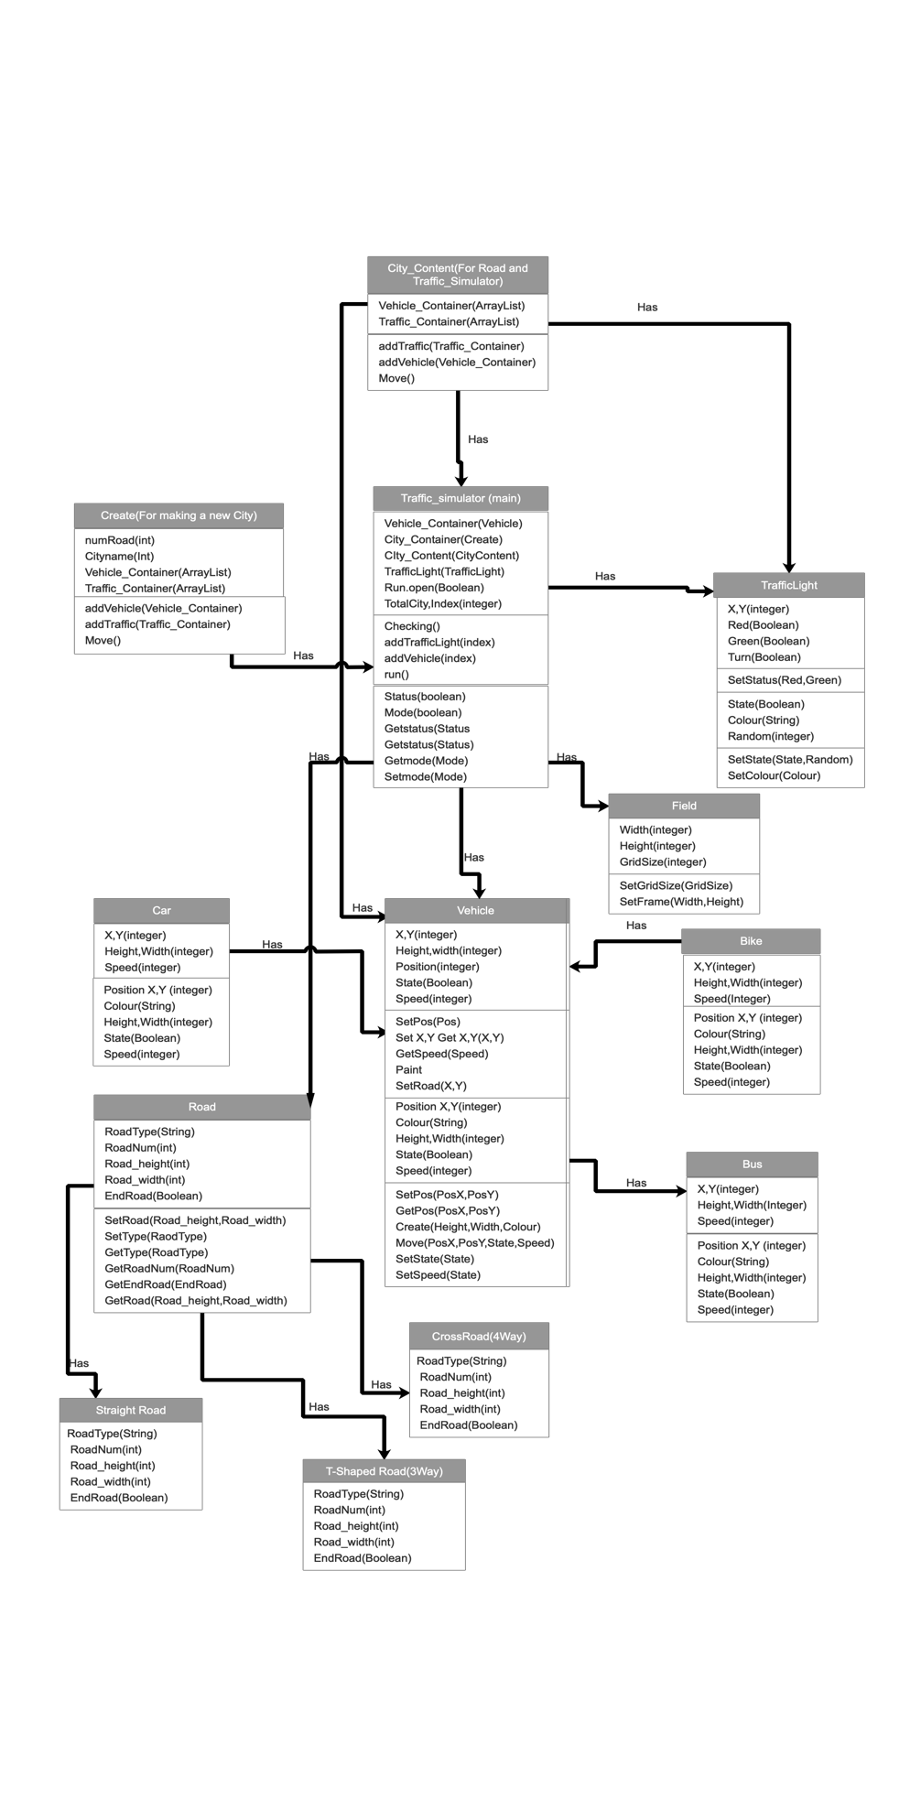

## **GitHub:**